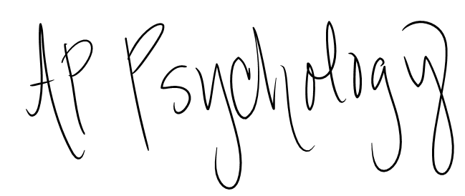

Summer Assignment

Welcome to AP Psychology! Words cannot express how excited I am you chose to take this class. You will find over the course of the year I am extremely passionate about the subject matter. Psychology can be found in every aspect of our lives. You will be amazed when you begin applying the knowledge you learn during this class to your life. As we start our journey we must remain mindful these are real life issues people are dealing with every day. One of my main objectives in the class is to broaden your understanding of human behavior helping you to recognize why we do what we do.

This is a college level elective class with higher expectations than other classes you will be taking this school year. This class not only introduces students to college level rigor, but also prepares them for the AP exam with the goal of **everyone** in the class earning college credit with a passing score. Your summer assignment is NOT meant to torture you, but rather to whet your appetite for the subject and give you a sneak peek at the topics we will be covering.

**Assignment 1- TED Talks**

For this assignment you will need to access the internet and watch SIX of the talks listed below. TED is a nonprofit organization devoted to spreading ideas in short, powerful talks in 18 minutes or less. TED is an acronym for technology, entertainment, and design. After listening to the lecture, you are to write a one paragraph summary of each lecture (so….. six paragraphs in all) consisting of at least seven sentences. Definitely incorporate any ideas or opinions you have about the lecture, as well as any terms or concepts you found confusing. Typing this assignment is greatly appreciated. ☺

**Due: August 21st**

Philip Zimbardo: The Psychology of Evil Dan Gilbert: Surprise Science of Happiness

Martin Seligman: New Era of Positive Psychology Susan Cain: Power of Introverts

Ben Ambridge - 10 Myths About Psychology Debunked Keith Barry: Brain Magic

Elizabeth Loftus: How Reliable Is Your Memory Tony Robbins: Why We Do What We Do

Angela Lee Duckworth: The Key To Success – Grit Pamela Meyer: How To Spot A Liar

Amy Cuddy: Body Language Shapes Who You Are

Shawn Achor: The Happy Secret To Better Work

**Assignment 2- “By Failing to Prepare, you are Preparing to Fail” – Benjamin Franklin**

This one is easy! Purchase what you need for class before the first day of school. No one likes to stand in long lines trying to get your supplies at the last minute. For this class you need:

* 3-ring binder (at least 2 inch) or subject notebook (It depends on how you like best to take notes. Some students prefer a binder others want a notebook so they don’t have to deal with pages falling out. Bottom line you need a reliable place for your notes.

Do what works for you!

* Pens
* Pencils
* Dry ears markers (skinny is best)
* Highlighters

Suggestion: purchase some type of review book for AP Psychology. There are several great options out there. You can order one from Amazon or go to 2nd and Charles to get a discounted copy. Below I have included pictures and titles. The covers may not look exactly like this depending the “edition” you purchase. I don’t prefer any of them over the other. They offer different layouts and approaches. I would go and look at to decide which layout you like best.

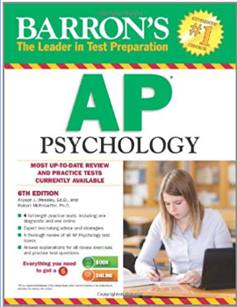 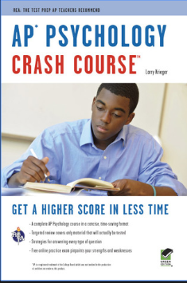 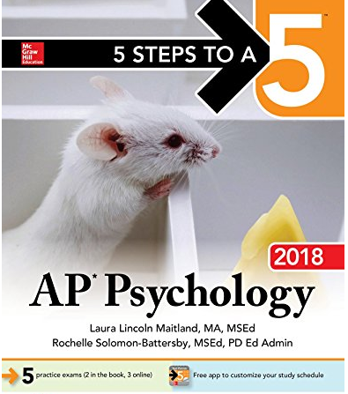

**Assignment 3- Eat, Sleep, and Be Merry!**

Get plenty of rest! As you’ll learn sleep deprivation is a major problem in our lives. Eat good food, spend time with family and friends, and have funnnnnnnnnn, I mean it is summer time after all.

Promises from me:

1. This class will be hard, but most of the time you won’t mind. You’ll just have to trust me on that one.
2. This class will be engaging and FUN!!!!!!
3. I will do anything I can to make sure you are successful in this class.

See you in August!!!!!!!!!

Mrs. Prescott